Multi-Agency Plan
Child Pack

Health
What a parent needs to give to a child/young person.....

What a child /young person needs…..
Home and warmth
Love and Care
Food and Drink
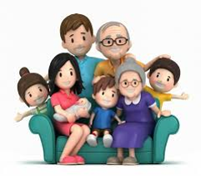
Family
School/college

Emotions
Friends
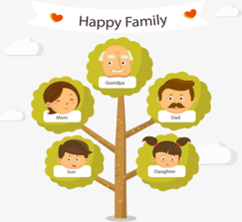
Family History
Family and home…..

Work / Money
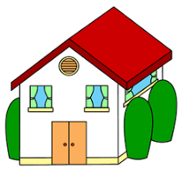
House, neighbourhood and town
?
Other Issues
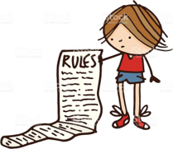
Rules
Toys and Games
Self-care-looking after yourself
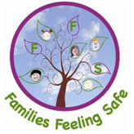
Feeling Safe

Why we are supporting you/current situation:

Child pack:
Each part of this pack is about areas of your life that are important. We will talk about each part together and discuss what is going well, the strengths, and what you may need some support with, the needs. Your worker may complete this over a few sessions with you. If you are unsure of any of the information, don’t worry, your worker will help you.
To help with this, each part also has a scale with numbers 1 to 10.
1 = It can’t get any worse. Things are not going well and they are not changing.
3 = Things aren’t going well but it looks like they could change. You and other people are working on it.
5 = Not unhappy, but not happy either. Some ok days, some not so good.
7 = Not quite there yet. You have a few worries and still need some support.
9 = Mostly where I want to be, mostly ok.
10 = Things are the best they can be. Everything is working well for you.
At the end of this pack you will put all of your scales into something called an outcome star. This helps you keep a track of the progress you make in the areas discussed.
Do you have any questions before we start?

N.B. For the practitioner completing this pack. All the questions under each heading are just examples that you may find useful to ask. You can any questions that you feel are relevant.

Example questions you could ask. What other health questions could you ask?
HEALTH:
- How is your health? Do you have any health conditions or disabilities?
- When did you last go to the doctors or dentist?
- What do you like to eat and drink? Do you eat fruit and vegetables?
- Do you sleep well? How much do you sleep?

1 2 3 4 5 6 7 8 9 10 (please circle a score between 1 – 10 to show how you feel about your health)

What is working well (Strengths)?
What needs to change (needs)?

EDUCATION:
- Do you attend school? Are you in on time?
- How do you find your school work? Are you struggling in any lessons?
- What do you like or dislike about school?
- What is your behaviour like in school?
- Do you stay in lessons or do you use other places at school like resource bases?
- Are there staff you can talk to if you need help or support?

1 2 3 4 5 6 7 8 9 10 (please circle a score between 1 – 10 to show how happy you are now with your education)

What needs to change (needs)?

What is working well (Strengths)?

FRIENDSHIPS:
- Do you have friends?
- Do you have a best friend?
- What do you like to do with your friends? Do you do any activities outside of school?
- Have you ever been bullied?
- Where do you hang around? Who with?

What needs to change (needs)?

1 2 3 4 5 6 7 8 9 10 (please circle a score between 1 – 10 to show how happy you are now with your friendships)

What is working well (Strengths)?

FAMILY:
- Do you get on with your family?
- What do you do as a family?
- What are your relationships like with your parents/siblings?
- Do you speak to any other family members that don’t live with you?
- Tell me what it’s like at home.

What needs to change (needs)?

What is working well (Strengths)?

1 2 3 4 5 6 7 8 9 10 (please circle a score between 1 – 10 to show how happy you are now around your family life)

HOME CONDITIONS
- Tell me about your home/where you live?
- How many people live in the home? Do you share a room?
- Do you feel safe at home?

1 2 3 4 5 6 7 8 9 10 (please circle a score between 1 – 10 to show how happy you are now with your home)

What needs to change (needs)?

What is working well (Strengths)?

BEHAVIOUR/ROUTINES/BOUNDARIES:
- Do you help at home? What do you do?
- What time do you have to be in? What happens in you are late?
- What is your behaviour like at home?
- If you misbehave, what happens?

What is working well (Strengths)?

What needs to change (needs)?

1 2 3 4 5 6 7 8 9 10 (please circle a score between 1 – 10 to show how happy you are now with this area of your life)

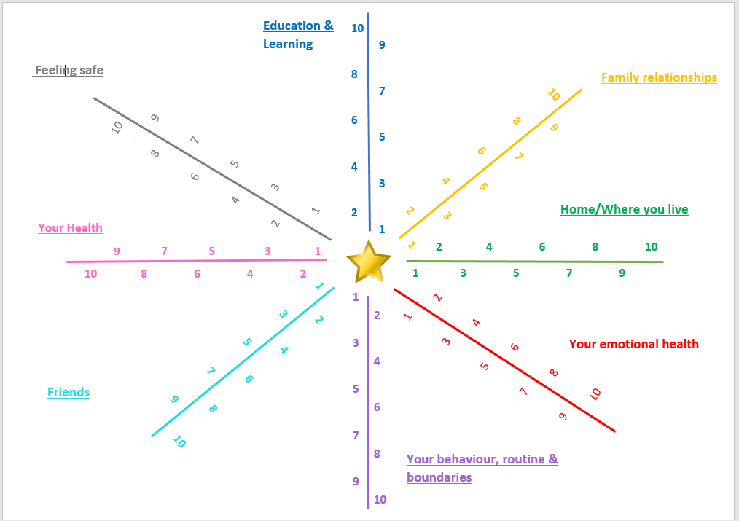

I have read and agree with the assessment.

Name of child/young person:

Date:

